Github link:
ERD Model PART 3
Illustrate that you understand normalization and how to use it to reduce uncontrolled redundancy in your database design by creating two ERD diagrams:

Answer: The normalization belongs with the customer details, order details, order status, payment and review. There are two sections in the normalization. One is customer details, order details and order status and another is payment and review.
Create the first using UML and the Umlet free utility.
Answer:
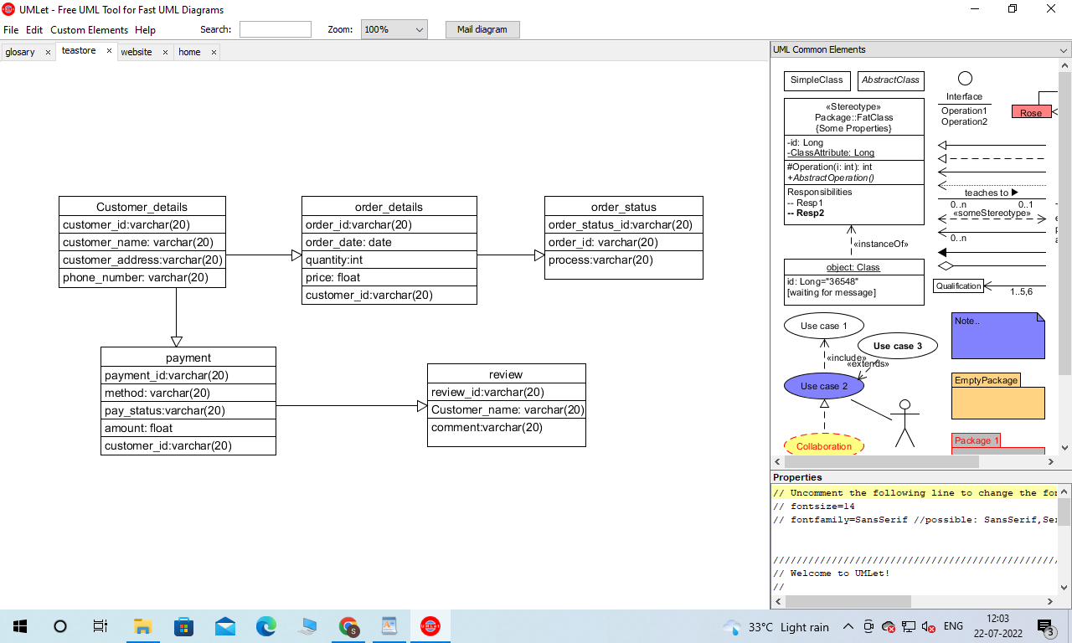

Create the second using Crow’s Foot notation in Vertabelo.
Answer:

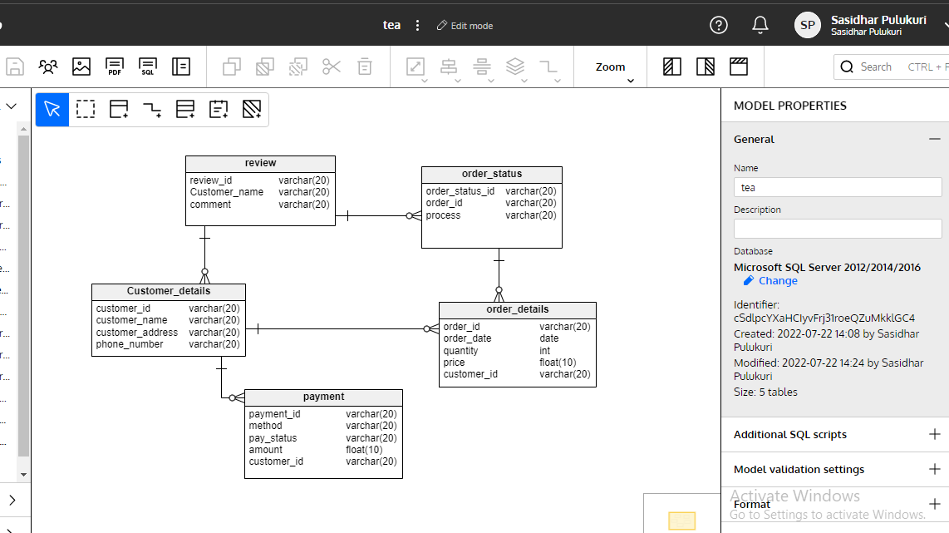

Upload both drawings to GitHub. The ERDs must both be physical models (includes data types and key information).

10 points for each physical model in GitHub for a total of 20 points.

See the help files in Blackboard, Week 3 for help using Umlet and Vertabelo.

